**CHFS Elementor Template Library Documentation**

**Step 1:**  upload plug-in zip file 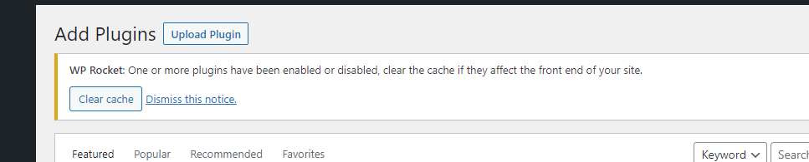

**Step 2:  
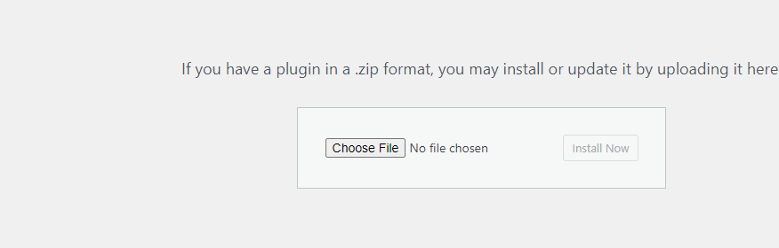  
Step 3:** Activate Plug-in and click on side bar menu of plugin

**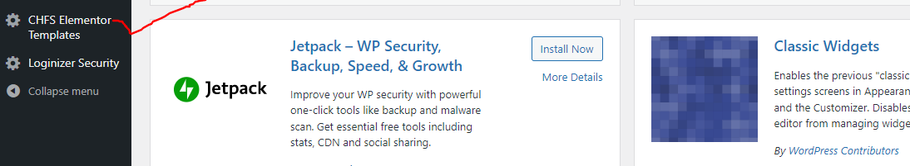  
Step 4:** Enter he api credentials email and password for authentication and also enable ch library with yellow button

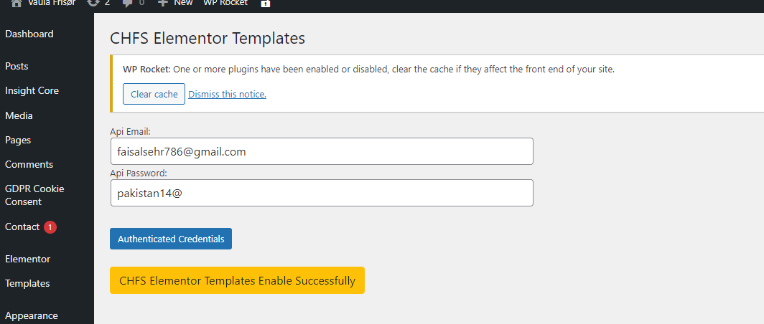

**Step 5:** Go to pages and edit page with elementor and click ch library button

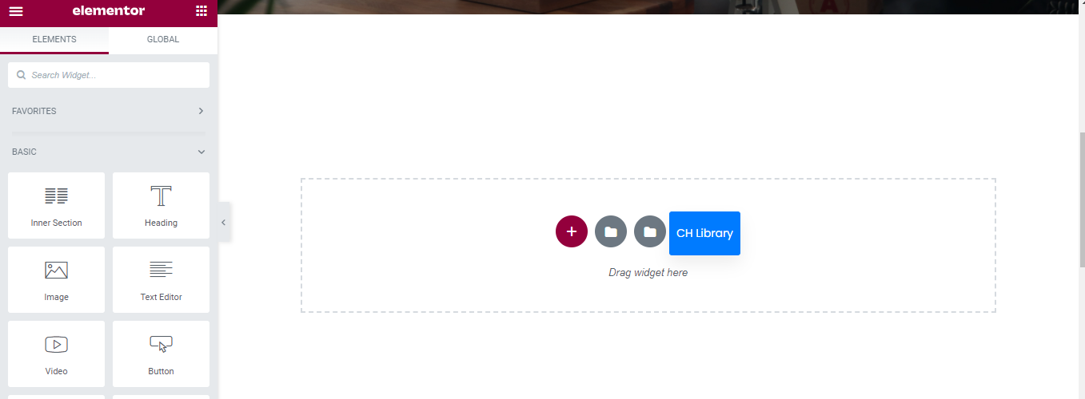

**Step 6:**

you see the template in form of grid and you search filter these templates and import and view also when you click import then template automatically add in to your elementor saved templates and you easily use this .

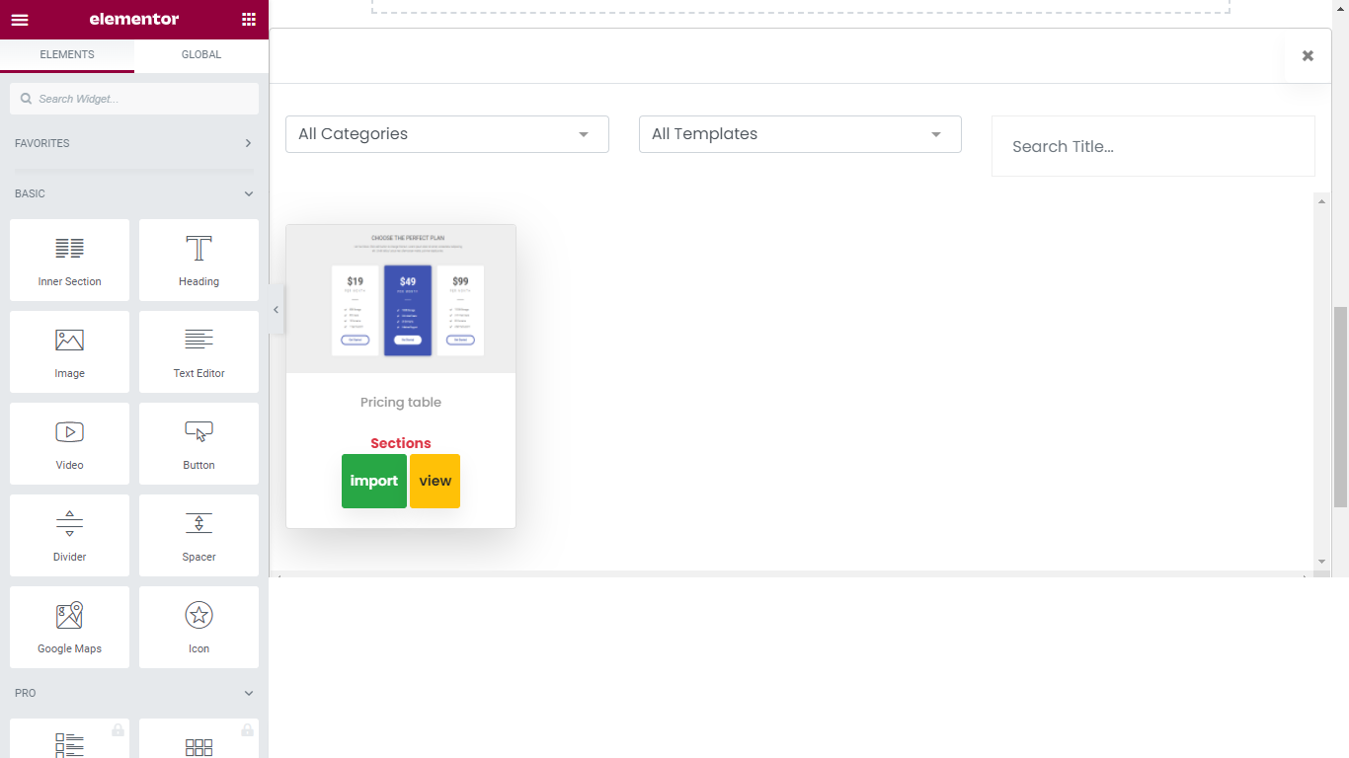

**Step 7:** imported template is visble in saved template of elementor you use easly

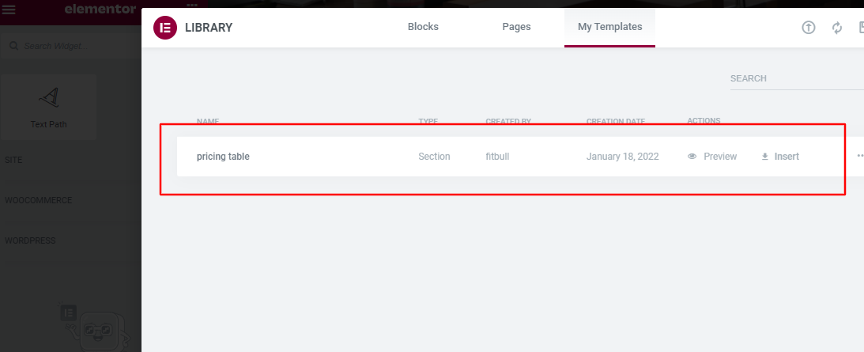

**CHFS Elementor Template Library Api Documentation**

**Step 1:** you loged in as admin

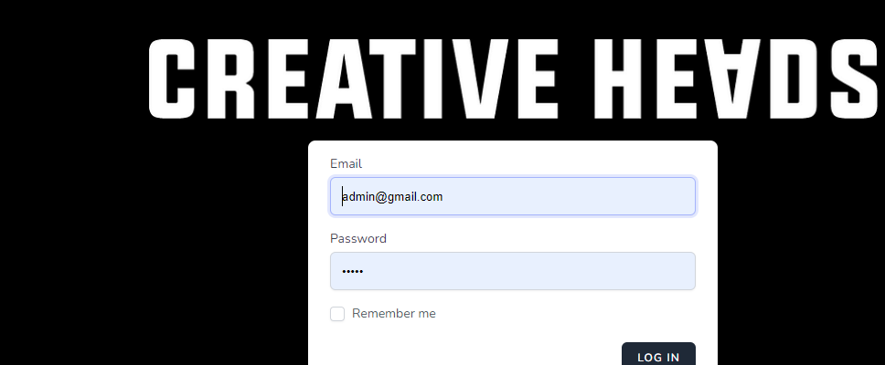

**Step 2:** you add user and you send credentials to user of library for authentication

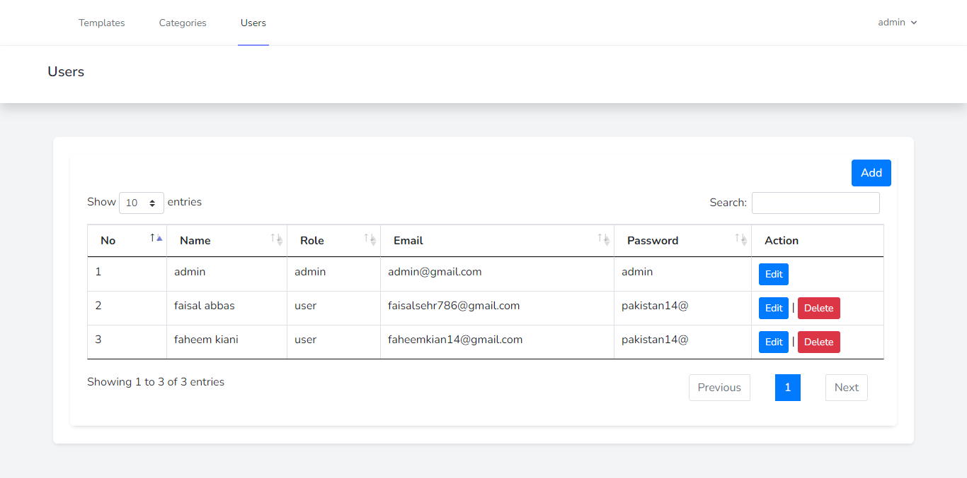

**Step 3:** add category for template

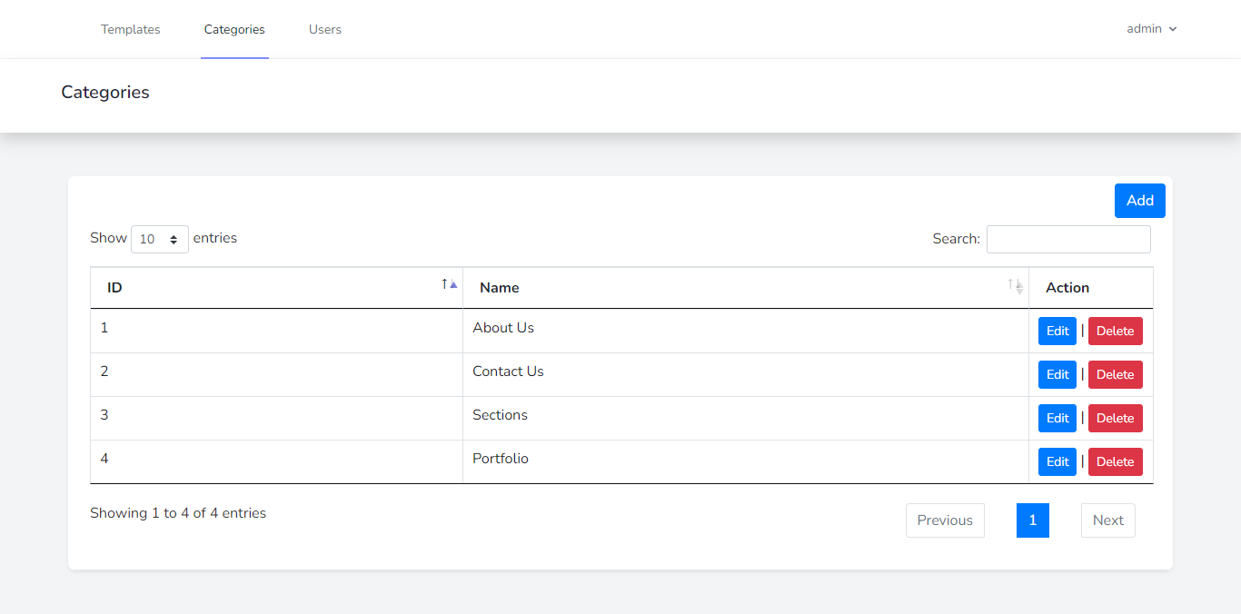

**Step 4:**

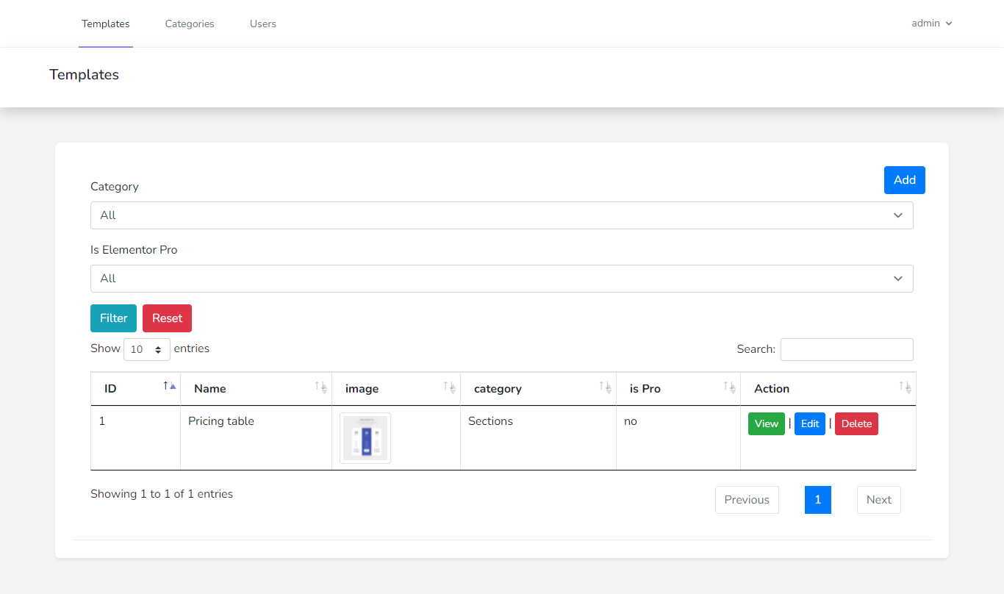

**Step 5:** here you add screenshot of template and json file of exported template from elementor and attach category

